Requirement Analysis

Problem stated

The A&H Operations and Learning Department has filed a request to improve the efficiency on the inputting the sales records from various partners and sponsors into System 6 database, which is known as enrollment internally. They are also facing human error for the enrollment of the sales record. There is a proposed automation from the IT department as a viable solution to such a problem.

Requirement of new solution

Functional requirement

The proposed solution will automate the process of the enrollment of the sales records.

Non-functional requirement

The non-functional requirement is the input given by the various partners and sponsors will be fixed, or unlikely to change. The other restriction is that the format of the enrollment accepted by System 6 is fixed and will not be able to change. Another non-functional requirement will be taken into account that the current solution need to cater to the current System 6 database and the future database adaption of System 6 known as System 6 Reno.

Stakeholders:

* Users: A&H Operations and Learning Department/ SSU
* Maintenance and support: IT Department
* Audit: external auditors

Establishing requirement

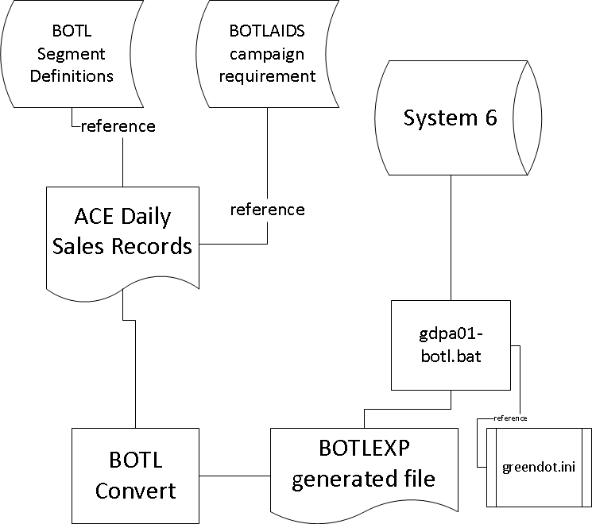

Figure 1: Data Flow of Partners' Sales Record

There are 2 methods to accomplish enrollment. One of the methods is illustrated in figure 1. The ACE daily sales records are provided by the various partners and sponsors. The sales records will be in excel format. Then referencing BOTL segment definitions and BOTLAIDS campaign requirements text file, the sales records will be going through a process/ program *BOTL Convert* to read the sales records and generate a BOTLEXP generated file to be uploaded into System 6.

The other method is to manually put in the data into System via a form in the Graphic User Interface provided for System 6.

[Pending screenshot on System 6]

Proposed solution outline

The solution will be split into phrases of implementation. Below is the brief breakdown of the implementation:

Pre-Version 1.0

Version 0.1:

Version 1.0: The program will be able to take in any reasonable format of sales records in excel file and reference any reason format of BOTLAIDS campaign requirement in rpt file. The program will generate a fully completed BOTLEXP generated file from the input.

Pre-version 2.0

Version 2.0: The program will be able to take in any reasonable format of sales records in excel file and **do not reference** BOTLAIDS campaign requirement file. The program will generate a fully completed BOTLEXP generated file from the input.

*Note that there may be more intermediate version before the final products of version 1.0 and 2.0 are launched.

Solution:

Note: there will not be any checking of input. All input are assumed to be correct.

Instruction on the usage of the BOTL Convert:

1. If the policy holder is the same person as the policy payer, users can leave the policy holder fields empty. It applies the same for main insured.